     

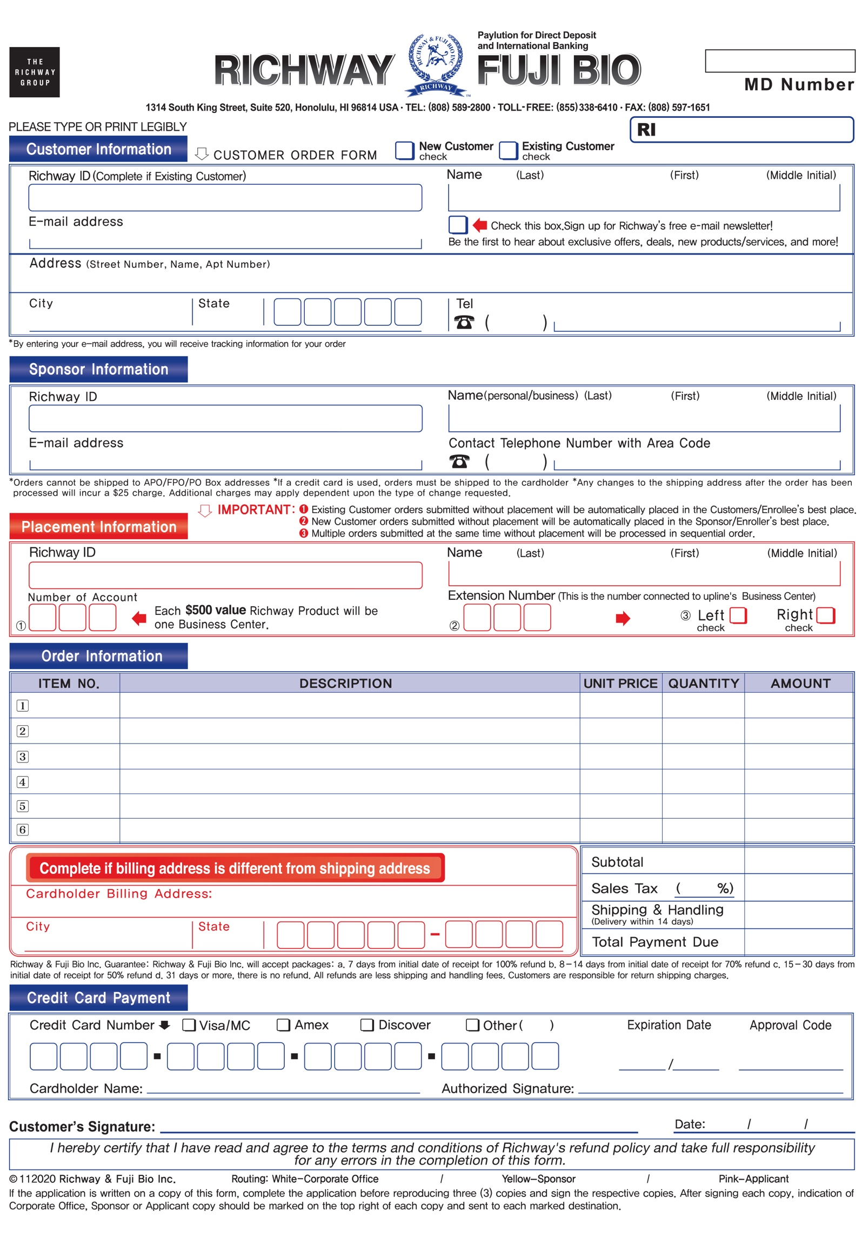

Price

Price

Enter item no.

Enter your description

Enter your description

Amount

Q'ty

0000

Enter your Cardholder Name

00 00

2024

000

day

month

0000

0000

0000

Amount

Amount

Amount

Amount

Amount

Price

Price

Q'ty

Q'ty

Q'ty

Q'ty

Q'ty

Price

Price

000 000

-

-

-

-

-

-

0000

00000

State

Enter your City

Enter your Billing Address

Enter your description

Enter your description

Enter your description

Enter your description

Enter item no.

Enter item no.

Enter item no.

Enter item no.

Enter item no.

000

000

Enter your Name

Enter your richway ID

Enter your Email

Enter your Name

Enter your richway ID

000 000

00000

State

Enter your City

Enter your Address

Enter your Email

Enter your Name

Enter your richway ID

000000

000000